Cameron Park

Community Services District

Agenda Transmittal

Date: February 19th, 2025

From: Kalan Richards, Battalion Chief

Agenda Item #: Fire Department Report

Recommended Action: Receive and File

Cameron Park Fire Department Incident Totals

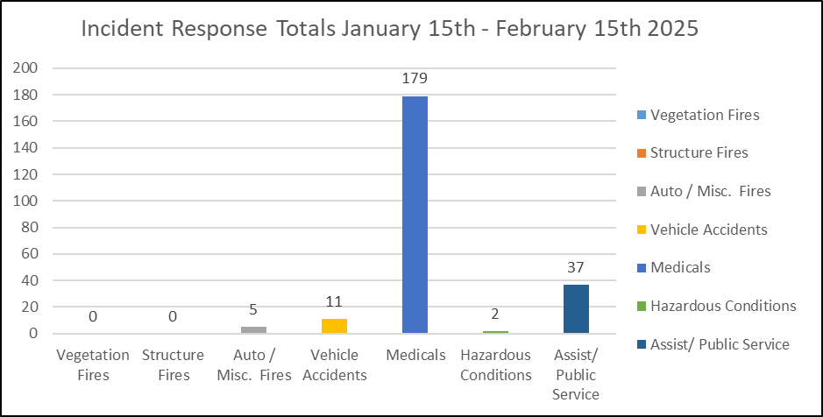

Total Incident Count Comparatives:
Monthly | December 2024 | January 2025 | Increase
 | 213 | 234 | 9.9%
Yearly | January 2024 | January 2025 | Increase
 | 210 | 234 | 11.4%
YTD | YTD 2024 | YTD 2025 | Increase
 | 297 | 319 | 7.4%

FY 24/25 Vehicle Maintenance and Tires
E89 | $23,230.02
E88 | $5,258.37
E289 | $2,429.01
E288 | $35.39
E388 | $1,493.00
B2705 | $1,841.14
B2715 | $2,844.50
U88 | $0.00
U289 | $95.61
Mech. Time | $0.00
Misc | $1,086.84
Total | $38,313.88
Budgeted | $62,000.00
Remaining | $23,686.12

Fire Apparatus Rental Income
FY 24/25

E89 | E88 | E288 | E289 | E388 | U289/88 | B2715 | OES T/F | Total
$0.00 | $0.00 | $1,431.13 | $16,601.08 | $25,576.19 | $365.20 | $15,657.19 | $0.00 | $59,630.79

Pending Payments
$81,990.21

- During the recent winter storm from February 1st to 7th, the California Office of Emergency Services, in collaboration with the El Dorado County Operational Area (XED), pre-positioned fire and rescue resources to manage flooding and increased call volumes.

The Cameron Park Fire Department, in partnership with CAL FIRE AEU, staffed and deployed its Type III Swiftwater & Flood Rescue Team, consisting of five technicians and a team leader, staged at Station 89 in Cameron Park. This team provides critical rescue and emergency response services to the community, county, and state.

- Last week, the region experienced another winter storm that brought significant precipitation. Cameron Park saw isolated flooding in creeks, roadways, and drainage areas, prompting an evacuation alert for neighborhoods near Deer Creek due to rising water levels.

This event created a high demand for sandbags in the community. In response, CAL FIRE's Ponderosa Fire Center deployed personnel to Station 89 to assist residents with filling and loading sandbags. This effort highlights the importance of partnerships, collaboration, and teamwork within El Dorado County's fire services.

